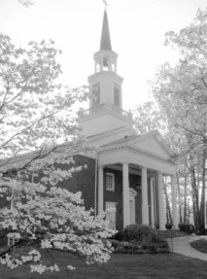

Fanwood Presbyterian Church

p.o. box 69

Fanwood, NJ 07023

908-889-8891

Senior Pastor

**Rev. David Jahnke**

Youth Ministries Director

**Lauren Comerford**

Director of Music Ministries

**Marcello Velame**

Church Administrator

**Lauren Comerford**

Director of Westminster Preschool

**Nancy E. Bantz**



**The Fanfare**

Fanfare Editor

**Chris Gray**

[**cgray1941@aol.com**](mailto:cgray1941@aol.com)

Production/ Fulfillment

Coordinated by

**Shirley Pillow**

Next Fanfare deadline is

**Dec 13, 2018**

For the Nov-Dec. issue

FPC on the web

<https://fanwoodpres.wixsite.com/fanwoodpc>

**Fanwood Presbyterian Church**

**"Growing in God's Love, Serving All God's People"  
through "Rejoicing, Renewing and Reaching Out"**

***PASTOR’S MESSAGE***

**Gratitude is the Key to Joy**

Give thanks to the LORD, for he is good; his faithful love endures forever. (Psalm 118:1)

I recently read that happiness does not come from gaining what we do not have but from appreciating what we have.  Amen! And what we have, generally speaking, is everything we need; from homes to live in, daily bread, good work to do, broken but redeemed families, friends, and everpresent Love, Peace, Goodness and Mercy.  So remember that everything is a gift and make Thanksgiving a daily holiday. Pastor David

**The Celebration of New Birth**

When the angels had left them and gone into heaven, the shepherds said to one another, “Let’s go to Bethlehem and see this thing that has happened, which the Lord has told us about.”  (Luke 2:15)

Christmas time is so lovely; our houses decorated, presents under the tree, delicious food and smiles everywhere.  It was very different the first Christmas; a long and tedious journey, an oppressive decree, no room at the inn, a dank, dark stable.  And yet new life came, the angels sang and the shepherds worshipped. God enters and brings new life to the earth not just when we make things right, but often when we make the biggest messes.  Cling to the assurance of his arrival.

‘No ear may hear His coming

But in this world of sin

Where meek souls will receive him still

The dear Christ enters in’

*(O Little Town of Bethlehem)*

**Welcome to Lauren Comerford!**

I am thrilled to introduce our new Director of Youth Ministries and Office Administrator Lauren Comerford.  Lauren hails from around Liverpool, England originally and now lives in Annandale NJ with her husband Brandon.

Lauren comes to us with a bachelor’s degree in theology and a post-graduate certificate in Secondary Religious Education.  She has had excellent introductions to our youth who are already falling in love with her and she will be teaching Sunday school with our teachers, in addition to leading youth groups.

She has shown tremendous technological skills and initiative (which happens to be the Sunday school curriculum theme this month!) in her first couple weeks of work, which included doing a ton of work on our new website which we have now launched.  Please keep her in your prayers come say hi to her during our new office hours below:

Monday, Tuesday, Friday: 8:30 a.m. – 1:00 p.m.

Wednesday: 1:00 p.m. – 4:00 p.m.

*Come meet and welcome our new office administrator Lauren Comerford at these times.*

*Go to the Thrift Shop from 10 a.m.-1 p.m. Wednesday*

*if the sanctuary is not open and you need to get in.*

Thursday: 10 a.m. – 12:00 p.m.

*David will almost always be in the office but please call to confirm.*



**The Launch of our New Website!**

Check out our new website at the address below (which may return to our old one if we decide to pay a little every month for a subscription.)  A great thanksgiving to Melissa Miller for getting this process started and a lot of hard work, to Hailey Kim for receiving the baton over the summer and to Lauren Comerford for completing the huge project:

<https://fanwoodpres.wixsite.com/fanwoodpc>

**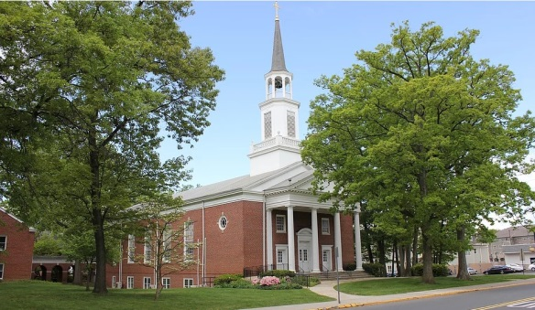**

**November and December Worship Schedule**

Nov. 4, 11-- 9:30 a.m. traditional and 11:15 a.m. contemporary services

Nov. 18-- combined 10:30 a.m. Thanksgiving service followed by potluck meal

Nov. 25 - Dec. 16-- 9:30 a.m. traditional and 11:15 a.m. contemporary services

Dec. 23, 30-- combined 10:30 a.m. holiday services

Christmas Eve, Dec. 24-- 5:00 p.m. Christmas pageant, 8:30 p.m. candle-light communion service beginning with special music

Exciting Opportunities for Mission at Fanwood

On the third Wednesday afternoon of every month, Fanwood adults and teens serve food to the community around the Shiloh Baptist Church on 4th Street in Plainfield. We gather at 3: 30 and return to Fanwood by 6: 15. This is a ministry of the Shiloh Baptist Seniors Fellowship who cook great meals for all attending. They appreciate our service very much. Please invite new Church members, and non-member friends who are interested in serving their community to join us.

Also, on Wednesdays, Fanwood folks minister at the Agape Food Outreach. Contact Carol Thomson for more details.

 Our annual Scouting for Food Drive is happening again on Saturday NOVEMBER 3rd! We would like to invite you, and any friends & family members you can persuade to join in the fun, to volunteer for a few hours on Sat 11/04/18 , to help the Food Bank stock the pantry for the festive season, and into the New Year.  The shifts are from 8:30 to 10:30 , & 10:30 to 12:30.  The more volunteers we have, the quicker the work will be done, but you may be having such a good time, enjoying the company of friends, new and old, that you might not want to leave! The work is suitable for All Ages - teenagers and children (with basic reading skills - one needs to read labels in order to sort the canned goods) with lots of energy are especially welcome! Please invite new Church members, and non-member friends who are interested in serving their community to join us.

Pastor Ken Macari for the Mission Committee: Jean Gray, chair, Iain Fraser, Sue Kelly, Darcie Lubalin

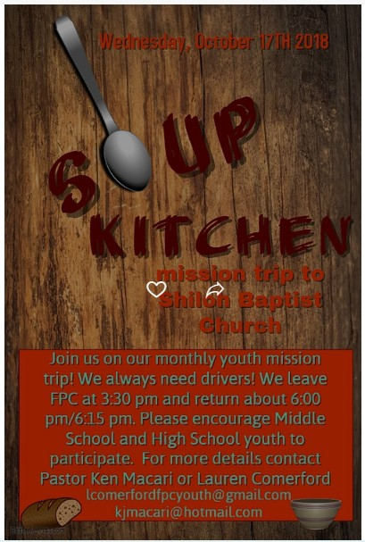

Join us on our monthly youth mission trip! We always need drivers! We leave FPC at 3:30 pm and return about 6:00 pm/6:15 pm. Please encourage Middle School and High School youth to participate. For more details contact Pastor Ken Macari or Lauren Comerford.

[**lcomerfordpcyouth@gmail.com**](mailto:lcomerfordpcyouth@gmail.com)

[**kjmacari@hotmail.com**](mailto:kjmacari@hotmail.com)



***MUSIC MINISTRY***

JOYFUL NOISE CHILDREN’S CHORUS - Please sign up your elementary school age children to be in Joyful Noise. Rehearsals are held in the sanctuary on Wednesdays from 5:15 to 5:45. You can send Marcello an email if you are interested or have any questions, at  [mvelame@me.com](mailto:mvelame@me.com)  .

8:30 PM Christmas Eve Service – We want to celebrate Christmas worship service with you and your family. Please, reserve that time to come glorify God with great music from the choir and string quartet and a wonderful Christmas message. We also hope you will invite a friend, who may not be yet committed that night. We hope to see you there on December 24th.

 

Hello from the food bank! We need volunteers for this year’s Boy Scouts food drive. The drive is on Saturday, November 3rd. We have two shifts 8:30 to 10:30 a.m.; 10:30 a.m. to 12:30 p.m. Please consider joining us for this special event as we need many hands to make this go smoothly. There will be sign-up sheets in the narthex. You can email Jean gray at  [fromage7703@gmail.com](mailto:fromage7703@gmail.com)

or call Susan Wayman at (908) 755-2330.

Thank you in advance.

**Advent Heifer Mission Project*,* December 9, 2018**

during Coffee Hour after worship in Westminster Hall. Sunday school will prepare the children for the Heifer Market immediately following the traditional service

\* Get some Christmas shopping done early with no lines and no hassle! You can “purchase” various animals as meaningful alternative Christmas gifts. A family in need around the world gets the animal and your friend or relative receives a Christmas card acknowledging your animal contribution in his/her name.

\*Support the FPC children and youth who sponsor this mission project. Involve yourself in mission by giving to families in need.

\*Involved in this mission since 1987, so far our children and youth have raised over $50,000 worth of animals for families in need.

\*Give a gift that keeps on giving hope to the hungry. A family that receives an animal pledges to give an offspring of their gift animal to another family in need. Thus your gift continues to give hope to others.

**Brighter Christmas Tree!**

It's time for the Brighter Christmas Tree Project.  The tree will be in the narthex by Sunday, Nov. 25.  Each tag represents a gift for the clients of United Family in Plainfield.  A small number of tags are specially marked as December birthday gifts for the Park Hotel residents.  After you make your selection, please use the sign-up sheet so we have a record of each tag.  Share a tag with a friend if the cost seems prohibitive.  Than bring your unwrapped gift along with the complete tag to the church no later than Dec. 9.  For questions, call Shirley Pillow at 908-889-5602

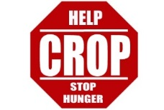

**Crop Walk Report**

Many church members walked to end hunger on October 14. Our community has raised about $7,000 so far, but you can still donate! Go to <https://www.crophungerwalk.org/> and search for **Fanwood Presbyterian Church.**

**educate_1953**

**Sunday school @FPC**

This Fall we started a brand new curriculum for our Sunday school. The “252 kids” curriculum has been a huge hit so far! It is very dynamic and it is jam packed with lots of different ways to engage our churches kids! The curriculum works around 3 videos that form the foundation of the lesson. Children then engage further with the Bible study concepts and passages through various games, activities, art and play. Learning does not stop on a Sunday for the kids either. Every week the parents get given a handout with some pointers on to help them discus the themes of this week’s Sunday school throughout the week also! Every month has a different theme and this month kids are learning about what it means to be content no matter what. The theme Bible verse is Luke 12:15 “Then he said to them, Watch out! Be on your guard against wanting to have more and more things. Life is not made up of how much a person has.” It is our prayer that our youngsters will begin to truly grasp these great Biblical teachings through these interactive Sunday school lessons!

**Youth @FPC**

Our youth groups have a very busy and exciting fall ahead! Coming up at the end of October is our Halloween event for the Middle and High school youth. This event is meant to be fun more than anything else! It will be a great time of fellowship together as we all get our fancy dress on and have some great laughs over some hilarious games and competitions! At the beginning of November we have our Mother & Daughter event. We are excited to come together as women and enjoy each other’s company over some great cakes and a nice warm cup of tea! We have guest speaker Debra Porowski coming to speak to our moms and daughters. Debra works as a vise principal at Hillsborough Middle School and is the Youth director at Faith Lutheran Church. We are excited for what she has to share! We are always looking for people to get involved somehow! So, if you love working with youth and children and want to get involved email Lauren at [lcomerfordfpcyouth@gmail.com](mailto:lcomerfordfpcyouth@gmail.com).

**A Word From Westminster Preschool**

  We are all enjoying the new school year tremendously and now looking forward to upcoming Thanksgiving celebrations and our favorite holiday, Christmas!

Thanksgiving is always a special time, as we learn all about the first Thanksgiving, enjoy our famous Feasts with our parents, and of course, dance the Turkey Tango, a Westminster tradition!

The teachers spend much time with the children discussing all that we are thankful for and what it means to be grateful. Our Friday worship lessons involve the same theme.

Then, before we know it, Christmas is here! This is such an exciting time for our preschoolers, they can hardly contain themselves!  I am very proud to say that our children also know that Christmas really is about the celebration of the day Jesus was born. Our amazing Christmas play is something to behold year after year. If you would like to come and see a heartwarming performance by our 3 and 4 year olds, please join us in Westminster Hall on Friday, December 14. All are welcome! The children will perform on the stage at 9:00 for our morning classes, and then at 12:00 for our afternoon classes. It is truly a wonderful way to feel the beauty and joy of Christmas!

Wishing everyone a very Happy Thanksgiving and blessing of the Christmas season, Nancy Bantz

--------------------------------------------------



**“PRESBYTERIAN WOMEN STRETCHING HANDS, MINDS AND HEARTS FOR MISSION”. Presbyterian Women are all women in the Church: we encourage each woman to take part actively in what-ever is of interest to her AND SUPPORT OUR ON-GOING EFFORTS.**

Small Groups or **Circles** of women meet for fellowship, service and Bible study.

***--------------------------------------------***

***Circles are open to all women and new members would be welcomed.*** Please call the leader of the Circle that fits your schedule.

If there is a program that you think would be of interest to the women of the Church or the Church membership, we would love to hear of it and make it happen. Call any of the Circle leaders or Cena.



**The Reading Group**

The next meeting will be Friday, November 9 at 1 pm in the Dining Room. The book to read is *The News of the World* by Paulette Jiles. Scotch Plains Library has one copy. The time of this novel is after the Civil War. Captain Jeff Kyle Kidd a former printer who lost his business in the war is now at 71 an itinerant story teller performing live readings from the newspaper for pay, enjoying his freedom. He is offered a $50 gold piece to take an orphan to relatives in San Antonio.

Johanna four years earlier had seen her family killed by the Kiowa Indians and raised her. She was rescued by the Army at age 10. She was small, thin and wild and she had forgotten English. Through the 400 mile travel through the unsettled and unforgiving land of corrupt government that brought anarchy and lawlessness she became closer to the man she call Kep-Dun. In San Antonio Caption Kidd is forced to make a choice that determined Johanna’s fate and his own.

This book was recommended by my Maine neighbor. All are invited to join us and come to the meeting on the 9th, if you have read this book or not. For more information please call Cena at 908-889-2029.

**⮚⮚⮚⮚⮚ November Birthdays ⮘⮘⮘⮘⮘**

|  |  |  |  |  |  |  |  |
| --- | --- | --- | --- | --- | --- | --- | --- |
| **Date** |  | **Date** |  | **Date** |  | **Date** |  |
| **1** |  | **9** | Richard Ledesma | **17** | Lenore Klein | **25** | Vicki Dembiec |
| **2** | Robert Lindermann | **10** | David Trumpp | **18** | Nicole Tanguy | **26** |  |
| **3** |  | **11** |  | **19** | Harrison McClure  Patrick Dembiec  Norman Schwartz | **27** |  |
| **4** | Amy Ledesma | **12** | Melissa Remo | **20** |  | **28** | Richard Warwick |
| **5** |  | **13** |  | **21** | Molly Van Ostenbridge  Ernest Watts | **29** | Ellen Geissel  Bing Prestridge |
| **6** |  | **14** |  | **22** |  | **30** |  |
| **7** | Sam Whitefield | **15** | Jonathan Gardner  Carol Thomson  Jocelyn Jenkins | **23** | Michelle Gustafson  Teresa Gustafson  William Henderson | **31** |  |
| **8** |  | **16** | Joni Elliot  Deborah Kinder  Darcie Lubalin  Christopher Turso | **24** | Evelyn Schneider |  |  |

**⮚⮚⮚⮚⮚ December Birthdays ⮘⮘⮘⮘⮘**

|  |  |  |  |  |  |  |  |
| --- | --- | --- | --- | --- | --- | --- | --- |
| **Date** |  | **Date** |  | **Date** |  | **Date** |  |
| **1** | Claire Swenson | **9** |  | **17** |  | **25** | Isabella Campanile |
| **2** |  | **10** | Benjamin Jackmin | **18** | Cynthia Gray | **26** | Michael Donofrio, Jr.  Cynthia Swindlehurst |
| **3** | Jean Gray | **11** | Donald Depew | **19** | Andrea Daniskas  Fiona Leahy  John Zwicky | **27** | Nancy Bantz  Martha LeWand  Barbara Prestridge  Albert Saum |
| **4** |  | **12** | Allison Tuyp | **20** | Regina Cardona  Danielle Shoback | **28** |  |
| **5** | Alan Krey | **13** | Grace Wayman | **21** | Samantha Knierim | **29** | Hailey Jahnke |
| **6** |  | **14** | Ryan Lahetta | **22** | George Zhelesnik | **30** |  |
| **7** |  | **15** | Christee Curran | **23** |  | **31** |  |
| **8** | John Spicer | **16** | Sally Depew  Seth Jahnke  Jasmine Lyons | **24** |  |  |  |

****

# Fanwood Presbyterian Church

## NONPROFIT ORG.

**U.S. POSTAGE**

**PAID**

**UNION, NJ**

**PERMIT NO. 333**

Box 69, Fanwood, N.J. 07023

Address Service Requested

bl00921_







**NOV-DEC**